## go SHOP

## SRS

Version: 1.0

Date: September 19th 2012

Presented by: **29th New York Volunteer Infantry Regiment**

|  |  |
| --- | --- |
| **Team Member 1’s Name** | **Charles Lander** |
| **Team Member 2’s Name** | **Ross Kahn** |
| **Team Member 3’s Name** | **Becca Dudley** |
| **Team Member 4’s Name** | **Jhossue Jimenez** |
| **Team Member 5’s Name** |  |

## System Summary

**Goals:**

To allow visually impaired people to use their phones to store their shopping lists

**Features:**

Color coded separators between the categories

## Existing Competition

**Go Shop!!!:** Go Shop!!! has categories however these categories are only distinguished by small text where ours will have a visual color bar separator between the categories. Our app will be simple and color coded for easier usability for the visually impaired.

**ShopShop:** A simple list where you can add items to the list and their quantities. When adding items, it remembers previous items for quick addition. Layout is simple, almost like a sticky note. Can cross off items from the list, and the shake the phone to permanently remove crossed out items from the list. Font size can be adjusted, but color cannot be changed. Our app will be able to color code items in addition to larger font size to help out the visually impaired.

**Grocery List Free(Shopping List):** You can add any items, but when you type in a letter; it displays pre-set items for quick addition. You can also look at the entire preset list of items, whose checkboxes are color coded. Tapping on an item will cross it out, and a second later will be removed and placed at the bottom of the screen. There that item can be permanently deleted, or added back to the list. The color coding on the list however are thin, hard to see colored tick marks, while our application will have the color coding be more visible and items won’t be deleted until the user chooses so and not accidentally taps an items and removes it.

**Smart Shopping List A La Carte:** When creating a list, various options can be added like a budget, and notes. Items added can hold various fields, such as categorized by “Aisles” and can even have photos attached. However, there is no color coding or anything that might help a visually impaired person. Our apps bigger font and color coding will offer more help to a visually impaired person.

## User Classes and Characteristics

|  |  |
| --- | --- |
| **User Class: User** |  |
| **Background:** | **May or may not be visually impaired. Some android phone experience but may be very little android experience.** |
| **Expectations:** | **Will allow the user to modify their shopping list as they think of items to buy, having their shopping list with them at all times. Allows the user to go shopping and not forget the list at home. Allows the user to modify the list as needed.** |
| **System Preferences:** | **Add item to list, check item off from list, remove item from list.** |
| **Domain Knowledge:** | **_x_ low ___ medium ___ high** |
| **Interaction Profile:** | **Frequency: _*x*_ low ___ medium ___ high (how often used)** |
|  | **Intensity: _x_ low ____ medium ____ high (when system is used)** |
| **Usability Objectives (rank in order of preference):** | **_7_ efficiency _4_ accuracy _3_ reliability _6_ learnability _2_ memberability _8_ clarity __5_ comprehensibilty _x_ attractiveness _1_ other:** |

# System Features

1. As a user, I can add an item to my list.
2. As a user, I can add categories to the list
3. As a user, I can change the category of an item.
4. As a user, I can cross off items that I have picked up.
5. As a user, I can remove all crossed off items at the same time.
6. As a user, I can add multiple items to the list at the same time, as long as they are apart of the same category

# Task Analysis

## Add item to list

* 1. Select category
     1. Hit arrow next to “Current Category”
     2. Select the desired category
  2. Type item into textarea
  3. Hit add button

1. **Add category to list**
   1. Hit menu button
   2. Select “Add Category”
   3. Enter new category name
   4. Hit “ok”
2. **Change the category of an item**
   1. Hit menu button
   2. Select “Manage Categories”
   3. Select category of the item to be changed
   4. Select “Move”
   5. Select category the item is to be moved to
3. **Cross off an item**
   1. Scroll down to the item
   2. Swipe finger to the right or hit the check box
4. **Removed all crossed off items**
   1. Hit menu button
   2. Select “Clear Marked”
5. **Add multiple items at the same time**
   1. Select category
      1. Hit arrow next to “Current Category”
      2. Select the desired category
   2. Add item
      1. Type item into textarea
      2. Hit add button
   3. Repeat task 6.a

# Nonfunctional Requirements

## Usability Requirements

* Adding a category should be done within two button presses(ignoring keyboard typing)
* The user should be able to add multiple items to the same category without needing to select the category each time
* The user should be able to add multiple items without having to select “add item” each time
* The user should be able to cross an item off the list by checking a box next to the item, or alternatively, swipe the item text

# Prototype

**1. Sample main screen**

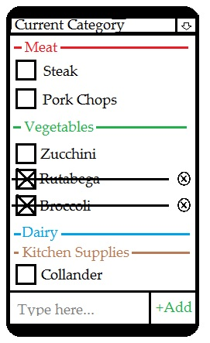

This prototype screenshot shows a sample of what the main screen will look like in GoSHOP. Starting at the top of the screen, there is a dropdown list of user-defined categories. Any item that is inserted, after one of those categories is selected, will be added under that category. Each category is color-coded. When an item is inserted, the name of the item will appear next to a large check-box, underneath the appropriate category. When the check-box is pressed, the item is crossed out. When an item is crossed out, it is sent to the bottom of the list under its category, and a convenient ‘delete’ button appears at the far end of the item. Finally, at the bottom of the screen, there is a text input box for a new item.

**2. Menu Popup**

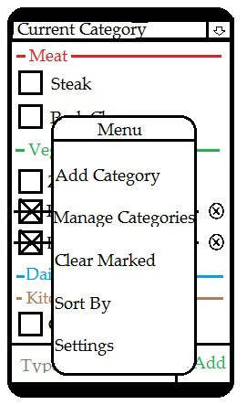

This is an example of the menu screen that will pop up when the user presses the “menu” physical button on their Android phone. Note that the menu options listed here are not necessarily the final ones, but instead just a few examples of what could go here.